Title (Times New Roman, 15pt, center alignment, bold)

Name Surname¹; Name Surname²; (Times New Roman, 12pt, authors separated by semicolon, underline the presenting author, center alignment)

*Corresponding author: ….@yildiz.edu.tr
¹Address: (Times New Roman, 10pt, institutions separated by semicolon, department)

Keywords: (Times New Roman, 12pt, no more than 6 words, separated by comma)

Type your text here (Times New Roman, 12pt, justify, single line spacing). Figures and graphics are welcome, but they are optional, and the abstract must fit a single A4 page (297×210 mm; 11.7×8.3 inch).

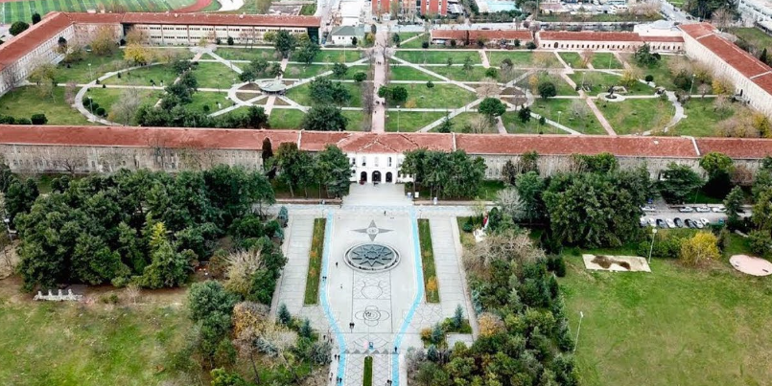
Figure 1: Figure Sample YTU Image

Acknowledgements: (Times New Roman, 12pt, justify, single line spacing)
References: (Times New Roman, 10pt, justify, single line spacing)
[1] First author, Book name, (2023)
[2] A. Firstauthor, B. Secondauthor, Journal name, vol:201, pp:57-62 (2020).
[3] A. MoreThanTwoAuthors, et al., Conference name, vol. 93, p.12 (2019).

